Money Management App

| **Laura Baeta**  92507  Instituto Superior Técnico  laura.c.f.baeta@tecnico.ulisboa.pt | **Diogo Fouto**  93705  Instituto Superior Técnico  diogo.fouto@tecnico.ulisboa.pt | **Francisca Ordaz**  93710  Instituto Superior Técnico  francisca.goncalves@tecnico.ulisboa.pt | **Hind Bakkali**  104789  Université Libre de Bruxelles  hind.bakkali.tahiri@ulb.be | **Stella Cristoforoni**  105197  Institut National des Sciences Appliquées de Lyon  stella.cristoforoni@insa-lyon.fr |
| --- | --- | --- | --- | --- |

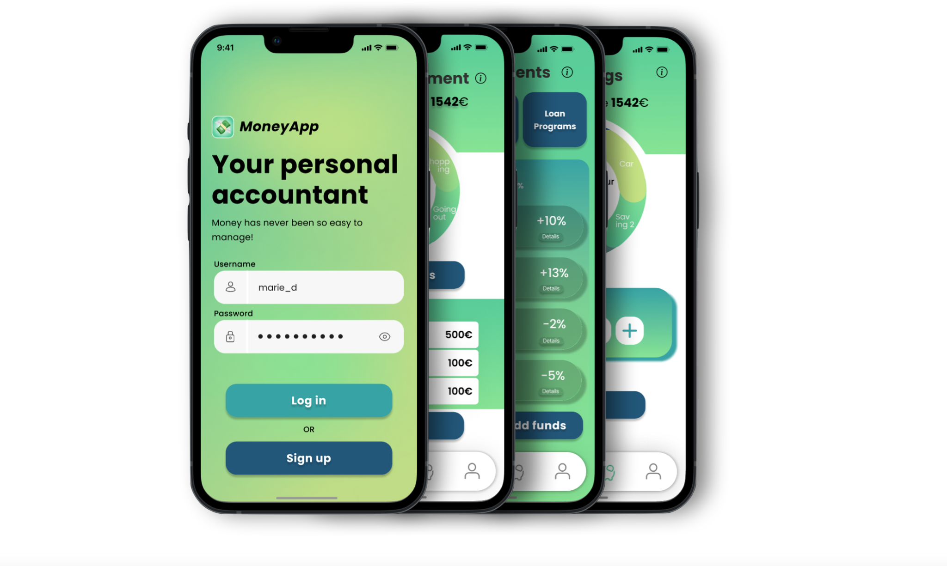

# ABSTRACT

Our work focuses on the financial practices and habits of young adults starting their professional journey. The main goal of this project was to create a user focused design to promote the financial wellbeing of our target group, as a strong foundation of financial literacy can help support various life goals, such as saving for education or retirement, using debt responsibly, and running a business.

We designed an interface with the assurance that it would solve the biggest obstacles that our user group faces when it comes to financial literacy. Here we summarize our work process, from the research plan, to the analysis of our findings, to the eventual creation of several prototypes, and finally we present the finished product.

## Author Keywords

Financial Literacy; User Focused Design; Financial Wellbeing; Money Management; Investment; Savings.

# CSS Concepts

• Human-centered computing~Interaction Design

# INTRODUCTION

In this report we present the app we developed with the purpose of responding to the needs of users in the group “*young adults starting a job*”. We will walk you through our process, our design choices and the research we conducted.

We hope that with this pictorial you will have a better understanding of how we got to this point and why we chose certain paths over others.

## Motivation For Choosing This User Group

The first step in this project was identifying the user group for whom we would be designing our app; after some deliberation we settled on “Young Adults Starting a Job”.

We chose this target group as it’s one we are particularly familiar with, since we all know a lot of people in this situation and were already privy to some of the particular financial struggles they face in their day-to-day life. On top of that, it’s also a demographic the five of us will soon be a part of, so, even though we made sure to take the role of designers and not users, we thought it would be interesting to create an app that our future selves could use.

Another important reason, and maybe the most relevant one, for choosing young adults just starting their professional journey stems from us realizing that they are in a particular interesting spot in terms of their financial understanding, as most of them are just now becoming financially independent and have never had to deal with their own finances up until this point, so we gathered that of all the user demographics they were probably the one in need of the dire help.

## Hunt Statement

“I am going to research how young adults starting a job manage their income and what their money-related goals are so that I can understand how to design a tool to help them manage their financial practices.”

## Research Plan

After deciding what our hunt statement would be moving forward, we needed to gather the relevant user data that would allow us to understand the needs of our target group in terms of their financial habits as well as their overall lifestyle.

The first step was determining a User Research Plan with the help of “User Centered Techniques”. We decided that each one of the group would interview around 2 people that belonged to the relevant user group using several different means: face-to-face interviews as well as interviews via zoom; sending the questions and receiving audios; a google form…

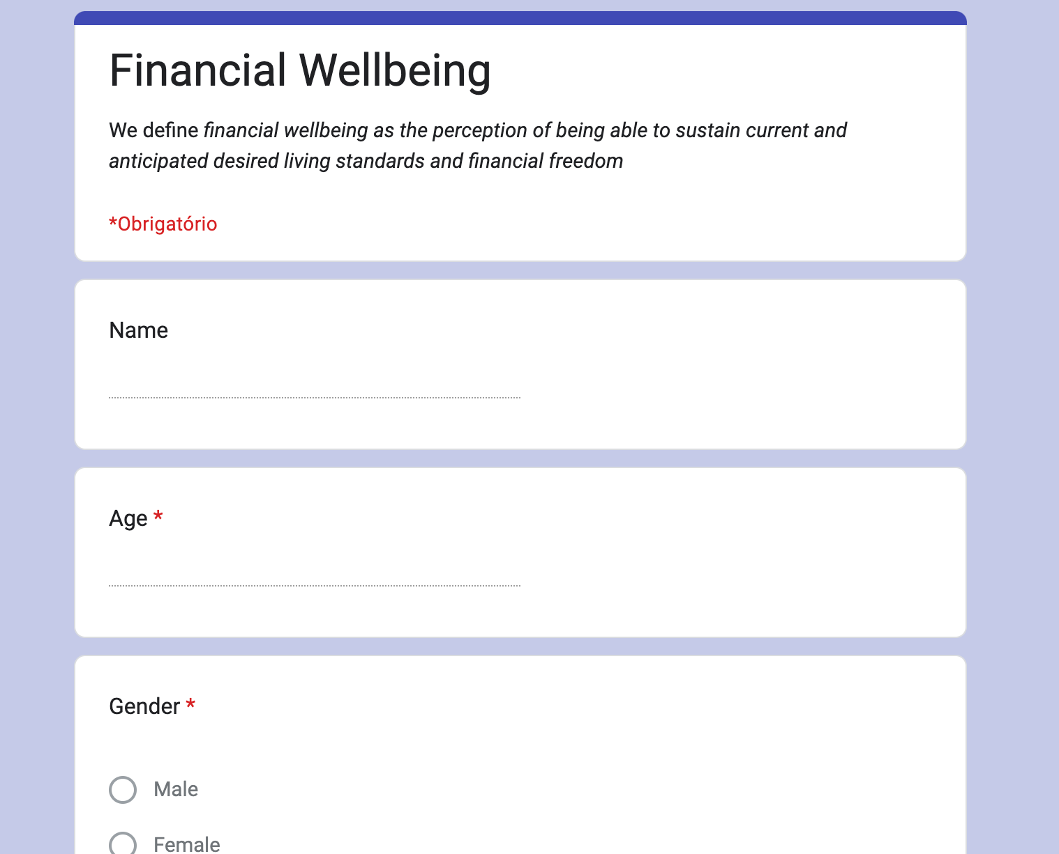

We then compiled the list of questions we were going to pose to our sample group. We divided them in four relevant sections: Demographics, Money-Related Questions, Life Goals and, finally, Well Being. We tried to blend financially motivated questions with more personal ones so we could have a better feel for the demographic we are dealing with as to better cater to their needs.

## Thematic analysis

After conducting user research, we started the data analysis process. This brought user insights which we encoded in the form a codebook, personas, scenarios, and contextual inquiry models. Let us see each in turn.

For the codebook, we selected three codes corresponding to the three aforementioned tasks: financial education, savings management, and investment management. For financial education, we wrote a description and fetched quotes from the user research like, “*I think that financial literacy should be done as a gamification in order to make things more accessible, like giving objectives, having data to see our evolution*”, and, “*it would be interesting to have financial literacy but can be annoying to have to read long stuff.*” For savings management, an example quote would be, “*I use 50% of it for monthly expenses and the rest is for savings.*” Lastly, for investment management, there is, “*Invest in real estate (in France), he wants to create his business, and repay his loan in 2-3 years (he is already starting to repay)*."

Based on the characteristics of the users in user research, we built three personas (which will later be tied onto the three aforementioned tasks). For each of them, we wrote personal details, personal situation, work situation, long-term goals, and savings plan.

The first is Marie (see the Figure below for her Empathy Map), a 25-year-old married young woman. She rents a house with her husband, has no children, no loans, and her salary is the only source of income. She works as a full-time plane systems engineer and earns 2000€ a month. In the next five years, she would like to buy a house with her partner and start a family. She also wishes to be able to visit another country once a year. As for her savings plan, she saves about 30% of her salary.

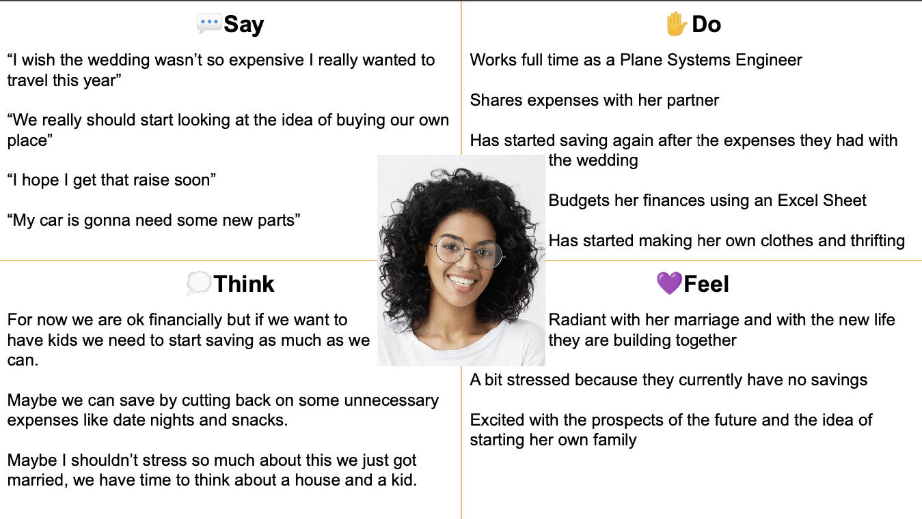

The second persona is Pedro, a 23-year-old man living with his parents. His source of income is his salary. His fixed costs consist of public transportation and a gym membership. His long-term goal is opening his own hostel and moving out of his parents’ house. As for his savings plan, he saves about 80%.

The third and last persona is Élodie, a 22-year-old student. She lives in a rented room with three housemates, and shares all her expenses with them. She has 15000€ worth of student loans, and her source of income are a salary and her parents. She works part-time in a gym and earns 650€ a month. Her long-term goal is to move to an apartment, buy a car, and pay off her loans before she is 30. As for her savings plan, she saves around 150€ per month.

We built a scenario for each persona (which we will later try to tackle and solve with our app). Marie’s is based on her “*We really should start looking at the idea of buying our own place*” quote: She needs to start saving so she and her partner can buy a house and start a family in 5 years time. They currently live and work in Belgium, in a rented house with her husband. Since they spent a large amount on their wedding she doesn’t have any savings for now. She is planning to save 30% of what she earns and save on clothes by making her own and thrifting more. Marie would like something that could help her manage her expenses along with her husband’s and put some money aside to achieve her goals, instead of only tracking the money they spend by using a spreadsheet.

Pedro’s scenario describes a basic story of an action or goal that a user wants to accomplish. He dreams of opening his own inn. He has researched a lot about loans and government programs, but is still anxious about taking the next step (“*This could go horribly wrong and I will be left in debt*”), which he plans on taking after saving enough. He’s highly skilled in researching loans and government programs, but is overwhelmed by all the workload he has to do by himself. He may need a convenient app to store all his loans and government applications, as well as a space to store his investment plans. This is so because the task of starting a business is a gigantic seven-headed monster.

Elodie needs to know more about finances when she is managing her money so that she can make better decisions to achieve her goals. She currently has a lot of different goals : she wants to quit her part time job to find a full-time job in her area, she would like to move from her shared flat to an apartment on her own, or with her partner. She is also planning on buying a car to make it easier for her to go to work and, most of all, she wants to pay her student loan of 15000 euros quickly. She really needs financial guidance to understand what she can do, what are the financial opportunities that she can have, and learn how she can manage her income in view of all her goals.

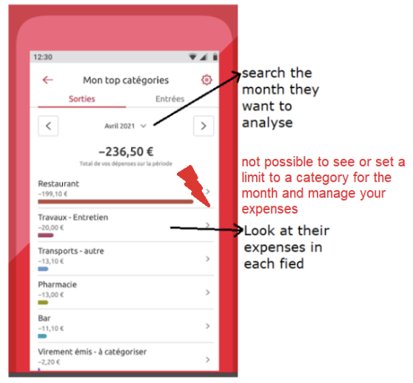

Finally, we discuss the contextual inquiry models. We build an artifact model and a flow model. The artifact model answers the question of, “how do you manage expenses?” It suggests an app for doing so. The figure above presents this model. The flow model answers the question of, “how does information flow?” It flows from the users’ needs to the app, which attends to those needs.

## Ideation and storyboards

After the thematic analysis came the time of the ideation. The purpose of this task was to find ideas that were really focused on the user needs that we had found previously, that is to say: saving planner, investment planner, money management and financial education.

With those themes in mind, we started the first step of our process: brainstorming. This step had the goal to come up with a lot of different ideas, with the “quantity over quality” sentence in mind. In order to do that, each member of the team had 20 minutes to come up with as many ideas as possible, at least 15. This step was done without any consultation between the members of the group to prevent the influence of the other.

The next step was to put all the ideas together in a document and order them by categories of needs in order to both organize and anonymize them. We initially reduced the selection to less than 5 ideas per theme, where each member could select their favorite idea from the document. After that, we discussed together the ideas that seemed the most relevant for each category, regarding the discussions that we had during the interview process, to select only one or two ideas by theme. It’s during this process that the number of themes went from four to only three: saving planner, investment planner and money management.

The ideas selected were, for the investment planner part: an option to get easy access to information and current (financial) news (interest rates in the country/bank, advice depending on the period and the economy, stocks news, etc.) and an option to visualize how an investment might go (e.g. enter income, what you want to invest in… and it creates an investing plan showing payments, time, at what moment it starts paying back, how much, etc.). For the saving planner having “shared” vaults so that multiple people can save up together and a calculator of how much time the user needs to reach their goals. Finally, for the money management, it was to set a monthly limit on categories (clothing, food, etc) and warn the user when he’s approaching or has reached the limit. We also wanted to put progress bars with how much you have paid off your debts.

To have a better idea of how those ideas would be integrated into our prototype we decided to make some storyboards. Those storyboards aimed to help us imagine the different steps of the journey of our personas and see if the ideas that we had selected were relevant in this context and how we could prototype them.

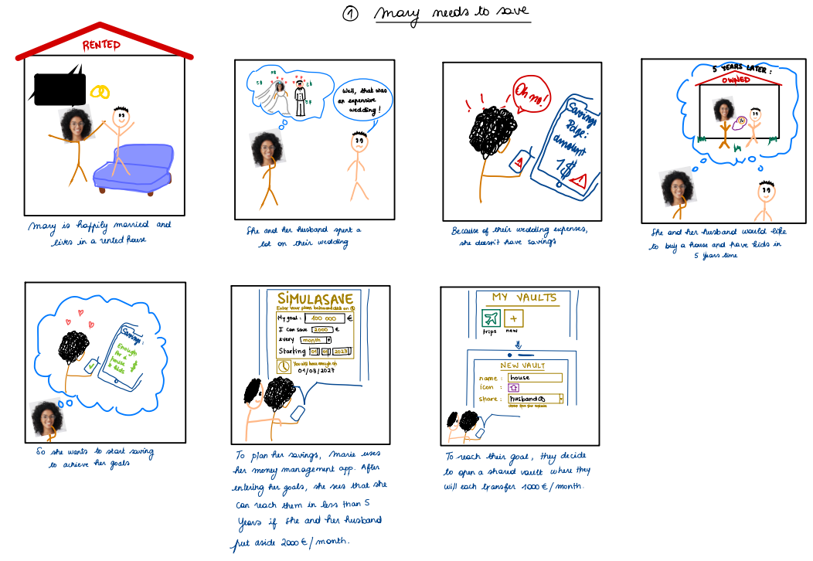

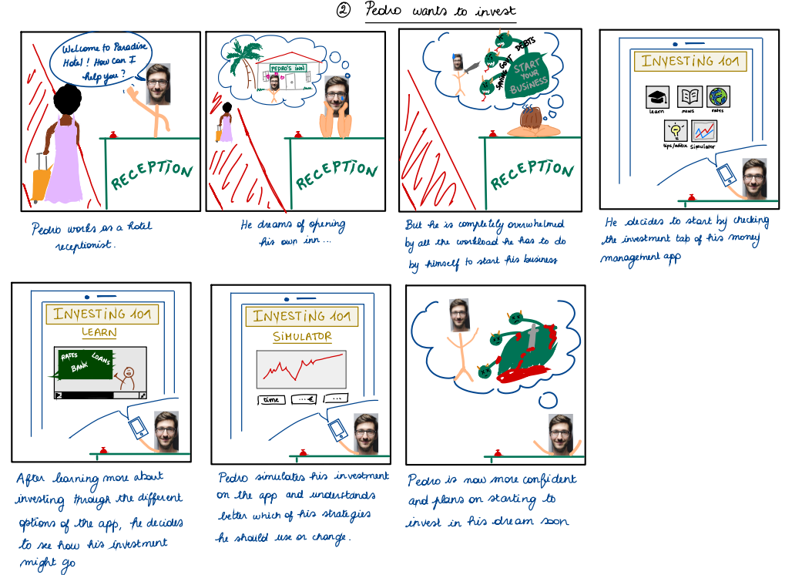

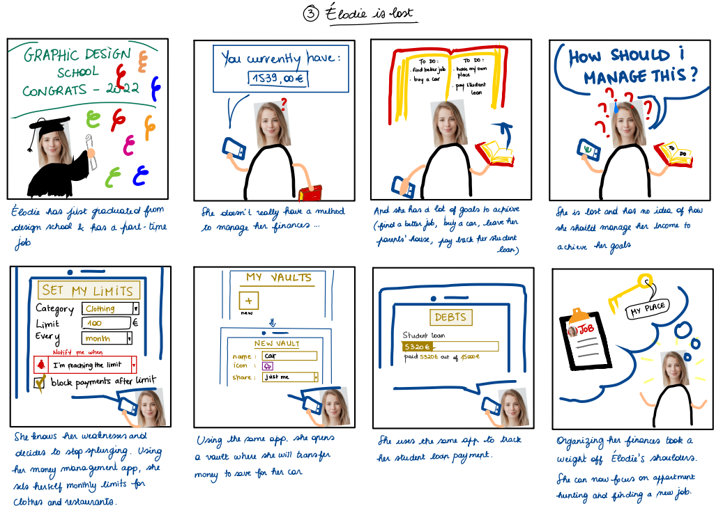

# prototypes

## Low-fidelity prototype

After analyzing the user’s needs and brainstorming, it was decided to develop an app containing 3 main pages : money management (expenses), savings and investments. The app would be linked to the user’s different bank accounts and would be constantly synchronized with their cards. Based on this idea, a low-fidelity prototype was built.

The first design is simple. At the bottom, a task bar leads to the 3 available pages : invest, save and manage.

The investing page contains a summary of your investments with possibility to invest more, an investment simulator to plan future investments, a *Loans and programs* button to know more about them, and an *Investment 101* button that leads to the investment education page. The latter contains a trends page (investing news), a learning page and a chatbot if help is needed.

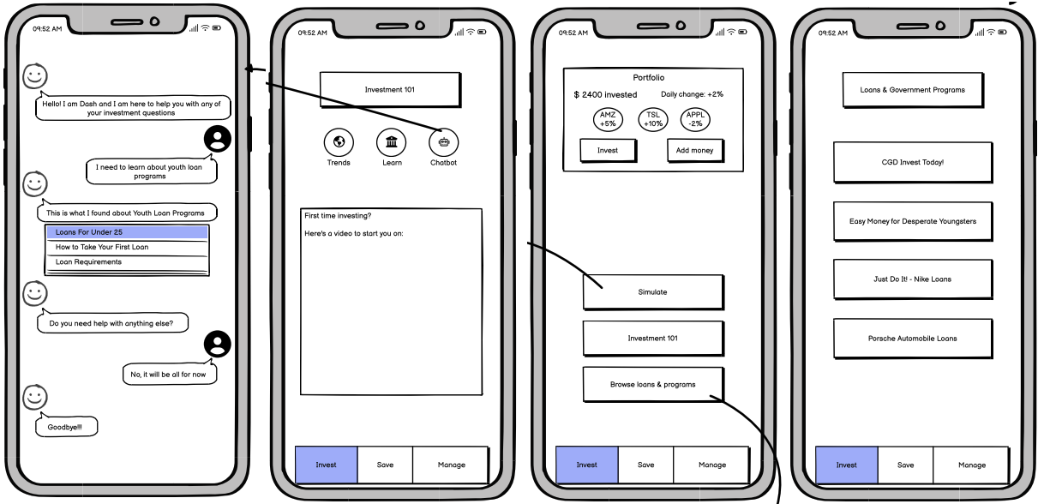

For the money management page, it provides 4 options :

* a summary of the user’s expenses represented as a pie chart for an easy visualization along with a bar chart and a table with the same purpose,
* an option to set limits over time for a certain category of expenses (with possibility of notifying the user or blocking their payments if the limit is reached),
* a debt tracker to see visualize the progression of the user’s debts,
* a vaults option that allows to create different safes to put money aside if needed (can be shared with a contact).

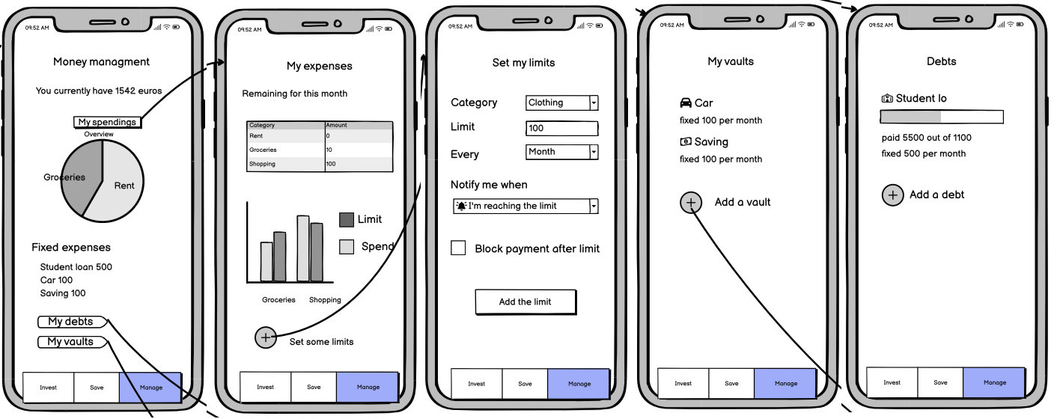

Lastly, the savings page provides a saving simulator that would allow the user to know how much time they need to save a certain amount of money, and an access to the vault option offered in money management.

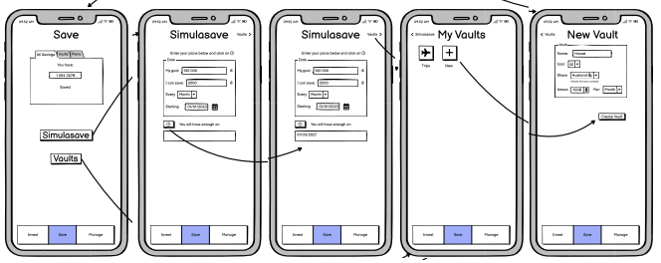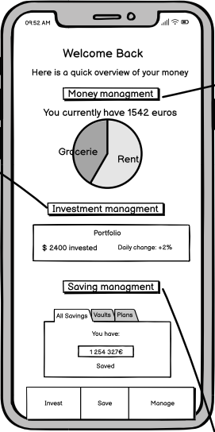

In addition, all 3 options are summarized in a welcome page : the user’s expenses represented in a pie chart along with their current balance, a portfolio of their investments and a block with different tabs linked to their savings (amount of savings, vaults summary, plans summary).

To evaluate this low-fidelity prototype, the sketches of the app were shown to different users whose opinion was collected. The feedback obtained contained comments about the design (fonts or buttons having to be changed) as well as remarks about unclear information (investing : "*what is Trends? Trends of what?*", expenses : "*the bar chart was a bit confusing*"). One user also suggested replacing the hyperlinks to external websites in *Loans and programs* by information available directly on the app.

## Mid-fidelity prototype

Based on the users’ comments, a mid-fidelity prototype was developed. First the design was improved : a bigger font, neater buttons and a new task bar to which was added a settings tab (note that the settings page was not implemented at this level). As for the options proposed in the app, none was added or removed, only improved. The missing pages that the buttons were supposed to link to were also added. For instance, pages such as *Learn* or *Simulation* were added to the investing section, which is the section that underwent the most changes.

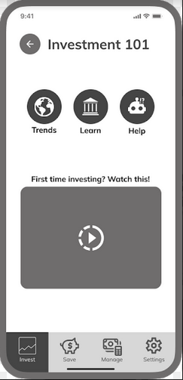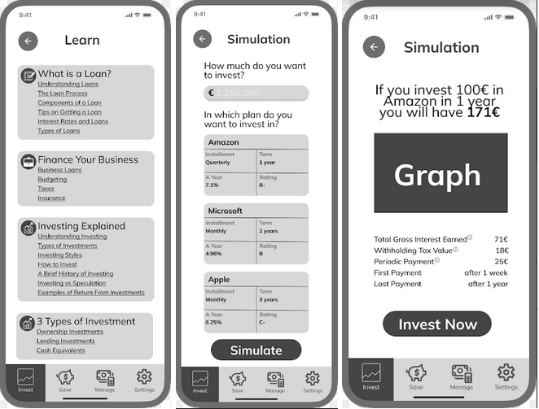

As suggested in the feedback, the hyperlinks in *Loans and programs* were replaced by in-app information.

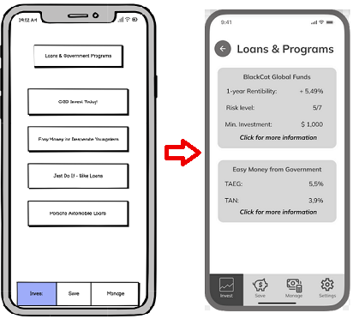

Moreover, the *My expenses* page of the money management section was redesigned : respecting the opinion of the users, the bar chart was replaced by progression bars which made the information much easier to understand.

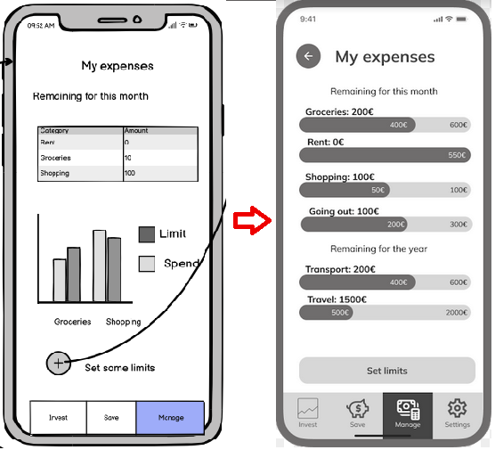

To evaluate this prototype, the method used was different from what was done with the low-fidelity one, which only consisted in sketches. Indeed, the users could interact with the mid-fidelity prototype and navigate through it. A few target users were thus asked to navigate freely through the app, and then complete 3 tasks :

1. use the chatbot to learn about investments,
2. set a limit of 200€ on evening out expenses,
3. find out how long it would take to save 2000€ for a car through the simulator.

These tasks each represent an action that the personas developed in the beginning of the study would need to complete, and allowed us to get precise comments about the options provided. During and after completion of the tasks, a member of the group took note of the oral comments of the users.

The overall opinion was positive as the users were able to easily complete all 3 tasks (“*loud and clear*”, “*The page to do the task is easy to find*”). However, they still had a lot of comments. About the design, they agreed on the fact that the fonts, icons and pages needed to be homogenized or that the purpose of some buttons was unclear or that some were missing (“*there is the need of having a clear button to trigger the resulting date of savings*” or “*The “help” name of the button is not really clear, the button needs to be called “chatbot”.*”). Some also noticed that some button-to-page interactions were missing or faulty.

As for the options provided in the app, the *Trends* page of the investment section left some users confused. When it comes to spending money, one user suggested being notified before paying, i.e. being asked to confirm any payment or important action. Users also asked about the missing *Settings* page which still had to be added. Lastly, we got questioned about how the app would access the bank accounts or how to make payments, to which we replied the feature still had to be added.

## High-fidelity prototype

After analyzing the feedback we received on the mid-fidelity prototype, we moved on to the high-fidelity prototype. The first thing we had to do was to agree on a consistent color palette to use on the whole app and a common design for buttons and pages in general. The next step was to, on top of adding each page, having the care to add them according to the user feedback. Our global priorities was to try to homogenize the whole app, make everything clickable and the transitions correct (especially the drop down menus, to give a more realistic feel to the simulations), change color of buttons when they were clicked on and increase the font size.

We added a login page as the starter home page and additionally placed the user page on the bar below.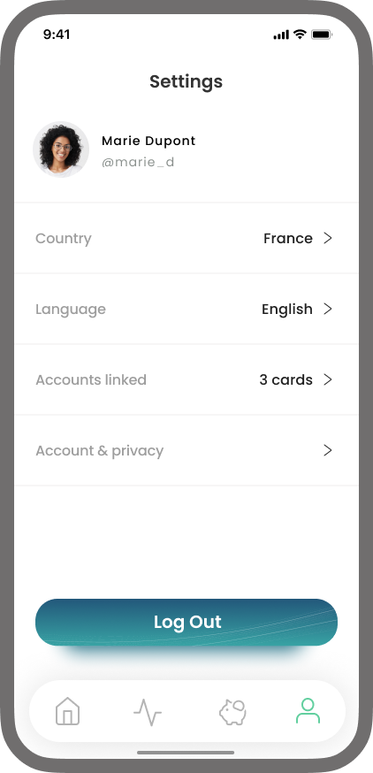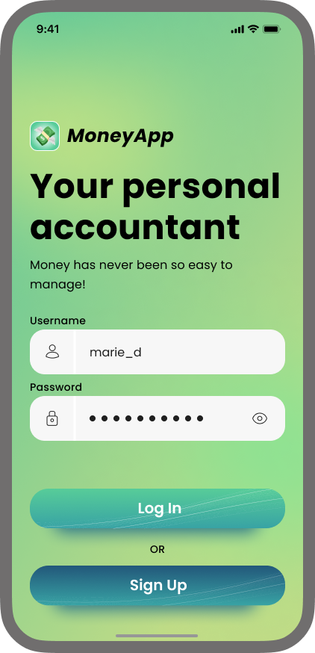

For the savings tab we simplified the existing widgets, made the buttons and the language more clear, solved existing inconsistencies and finally added icon options, simulation name and an option to simulate according to a limit date.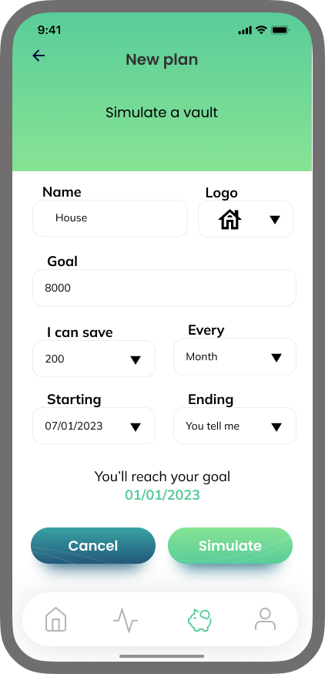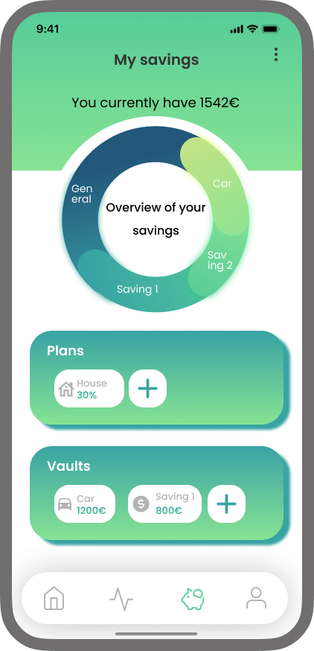

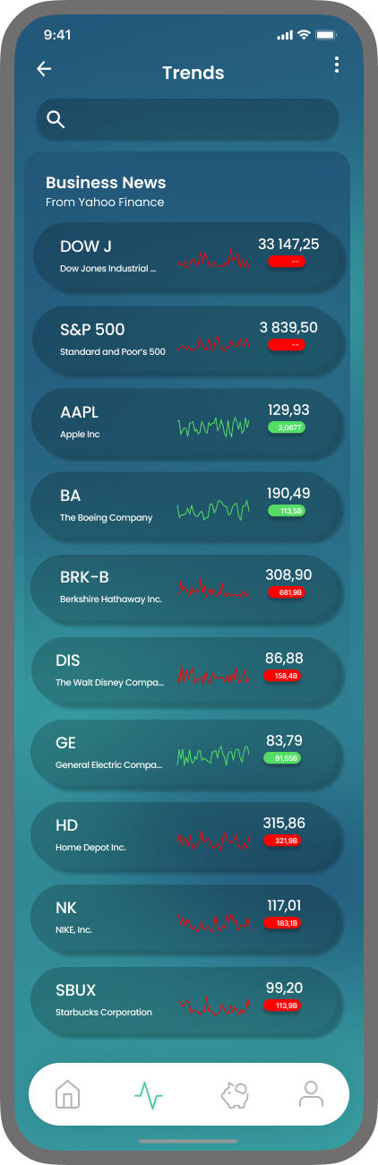

On the investment tab we added the possibility to view trends (right image). And finally, on the money management tab, we added captions to the pie chart (bottom image). 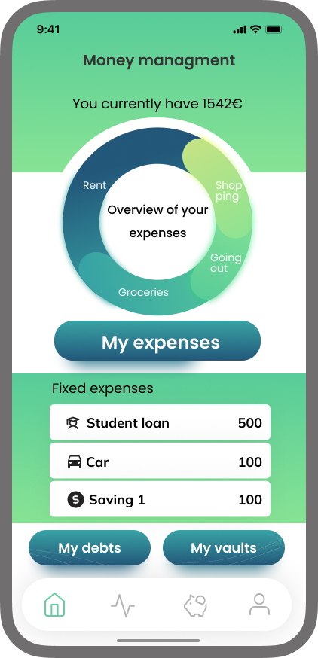

We received positive feedback in the user tests we conducted. We got a 67,95 SUS score on our first high fidelity prototype, so even though it’s not on the “*acceptable*” side of the scale, we had sufficient information to iterate our prototype and make it better. From it we deducted that we should: add a button info on the main pages, increase the contrast on the task bar as well as the font size on the titles and make the buttons less confusing.

In the investment tab we were told that there was too much space in the chatbot, that the light background color with white text color on some blocks made it hard to read and that buying stocks should be more intuitive.

On the money management task we should make some information such as *"you have ... €"* bigger. We also received the feedback that having the option to view/edit vaults on this page was redundant since they were also on the saving page. Lastly, users also said that it should be easier to find the limits.

On the saving tab we were told that the plans feature was confusing, with the suggestion that a simulation button would be clearer and with a note that vaults should have a goal as well. 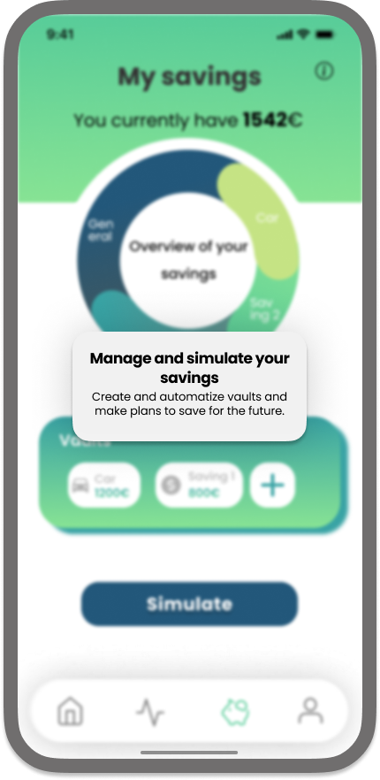

## Final prototype

For the final prototype, we started by adding an info button that showcased more information while hovering above it. We also changed the task bar and pie-chart colors and homogenized the buttons by making them all smaller, removing the shadow effect and making them the same color.

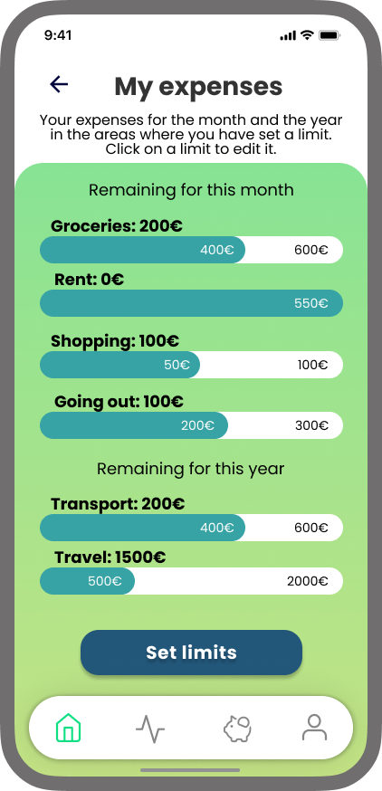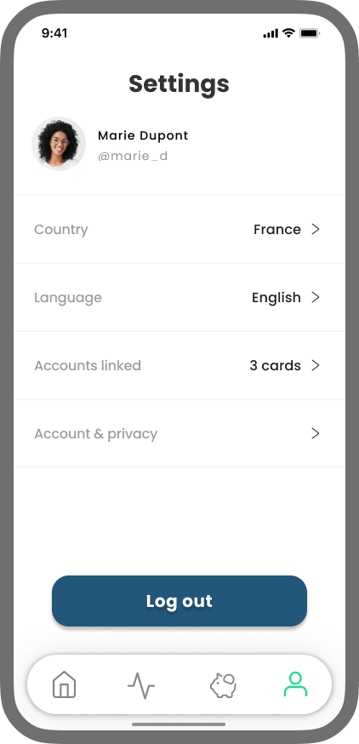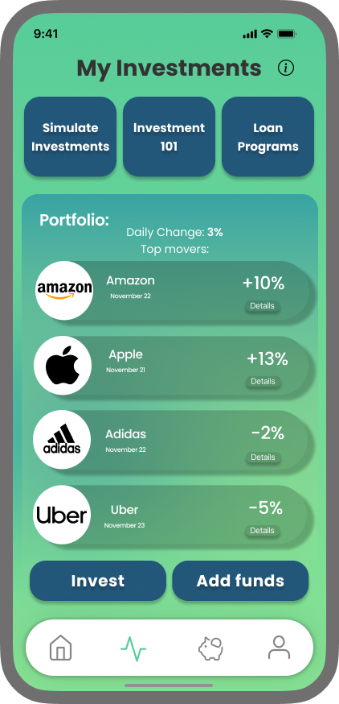

On the money management section: we increased the size on the text that indicates the amount of money and removed the vaults. Additionally, the "*my expenses*'' page background was altered to fill the whole page, and the title "*remaining for the year*" wasn't really clear and so changed to "*remaining...*".

On the savings tab, we got rid of the plans widget altogether and decided to have just a simple “*Simulate*” button. Besides that we added the option of defining a goal to the vault.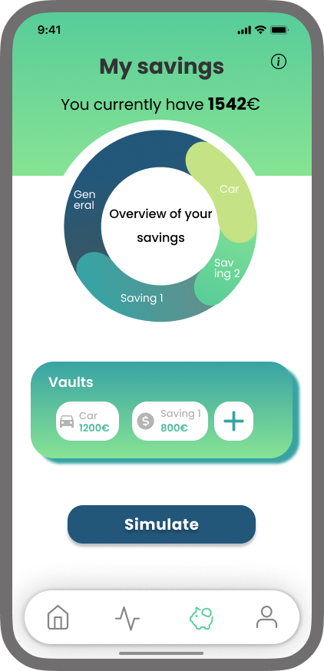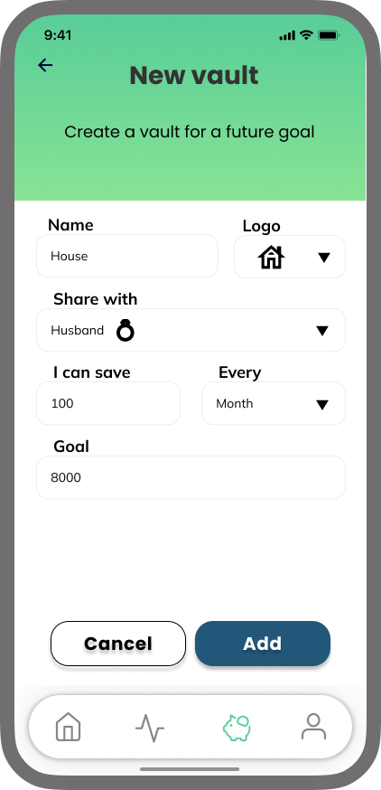

In respect to the investment page, some elements that were clickable didn’t appear to be so, making the investment 101 section confusing. The space in the chatbot was solved, as well as the contrast in that tab. When buying stocks, we added a confirm message for increased security and altered the interface on this part so it would be less confusing.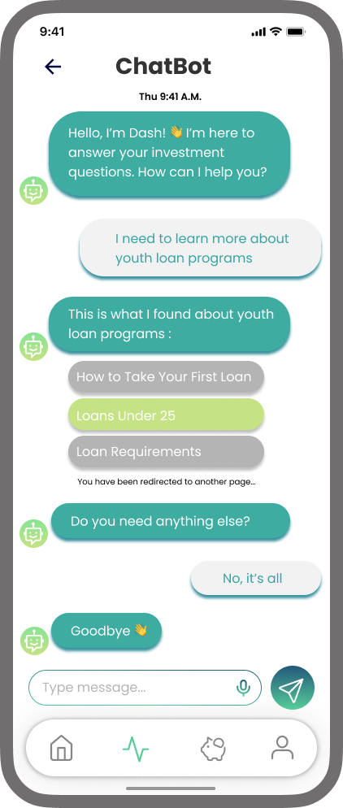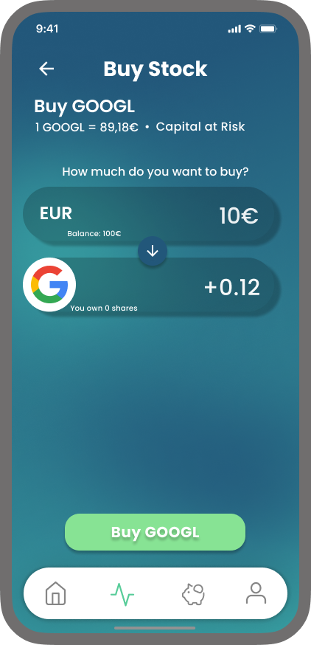

Regarding the login page, a notification was missing when we clicked on “*login*” without accepting the terms and privacy so we added it for clarity.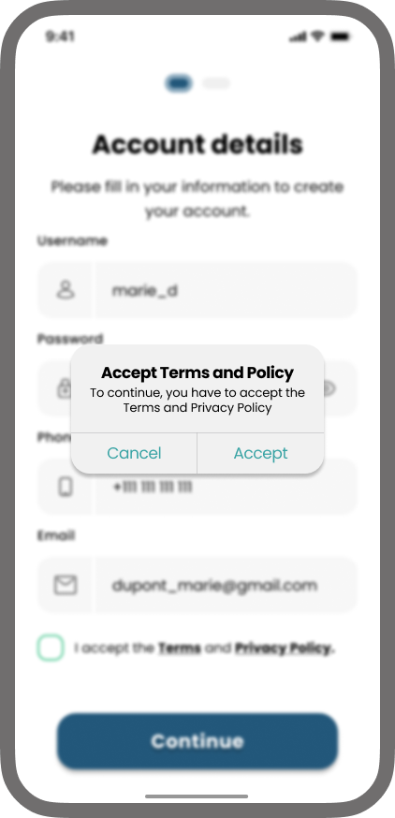

## 

## Why is our product valuable?

In the first place our product responds to the needs of our users. They felt the need to learn about investment, the need for a tool that could help them plan ahead in their future and manage their expenses in the present. Our app responds to all of that, making it versatile and useful.

We were also very rigid on following the feedback that users gave us, bringing them closer to the product and tailoring it to them, on a usability level.

With all of this, our product stands out in bringing together a lot of tools and features that are usually scattered on our phone through an endless amount of apps. It makes the task of dealing with money simpler, easier and faster with its cohesion.

## Conclusion

In this work, we built a money management app to help young adults starting a job learn the intricacies of finance. We conducted user research, constructed personas and scenarios based on it, and, step by step, built our prototypes. The final work tackles the tasks we set out to solve and, we believe, is a good solution for helping the aforementioned users better manage their money.

## Acknowledgements

We thank our wonderful teacher Beatriz Severes, who provided helpful comments on our project and made this a worthwhile endeavor, and all our users who helped by participating in the user research and prototype evaluation.